TRIGEL: Tri-class Guided Multi-dimensional Graph Enhanced Contrastive Learning for Imbalanced Cancer Subtyping
- Introduction
Cancer subtype classification plays a pivotal role in precision medicine, as it can support individualized treatment and improve patient prognosis. However, cancer data commonly suffer from data imbalance. In addition, different molecular layers vary substantially in dimensionality, sparsity, and information content, hindering the effective integration of multi-omics data. These issues severely constrain the accuracy of cancer subtype classification. Therefore, addressing both data imbalance and multi-omics fusion remains an important challenge in cancer subtype classification.
Data imbalance manifests at multiple levels, including class imbalance among subtypes, feature imbalance across different omics modalities, and topological imbalance in graph representations [1,2]. Existing methods for addressing class imbalance mainly operate at the data level, the algorithm level, or through ensemble strategies. For example, SMOTE [3] generates synthetic samples by interpolating within the feature space at the data level, thereby alleviating data imbalance. However, when minority-class samples are extremely scarce, this approach may fail to adequately capture the true data distribution. GAN- and VAE-based models address this limitation from an algorithmic perspective by learning the underlying data distribution to generate more realistic synthetic samples [4,5]. In contrast to methods that directly modify the data, focal loss [6] adopts a cost-sensitive strategy to handle imbalance by down-weighting well-classified samples, enabling the learning process to dynamically focus on difficult minority-class samples. Ensemble strategies further improve robustness by aggregating multiple learners trained on rebalanced subsets [7,8]. Nevertheless, most of these methods simply divide samples into minority-class and majority-class. This binary division is too rough to describe the internal distribution structure of data, and it is difficult to adapt to the common gradient imbalance characteristics in multi-omics data.
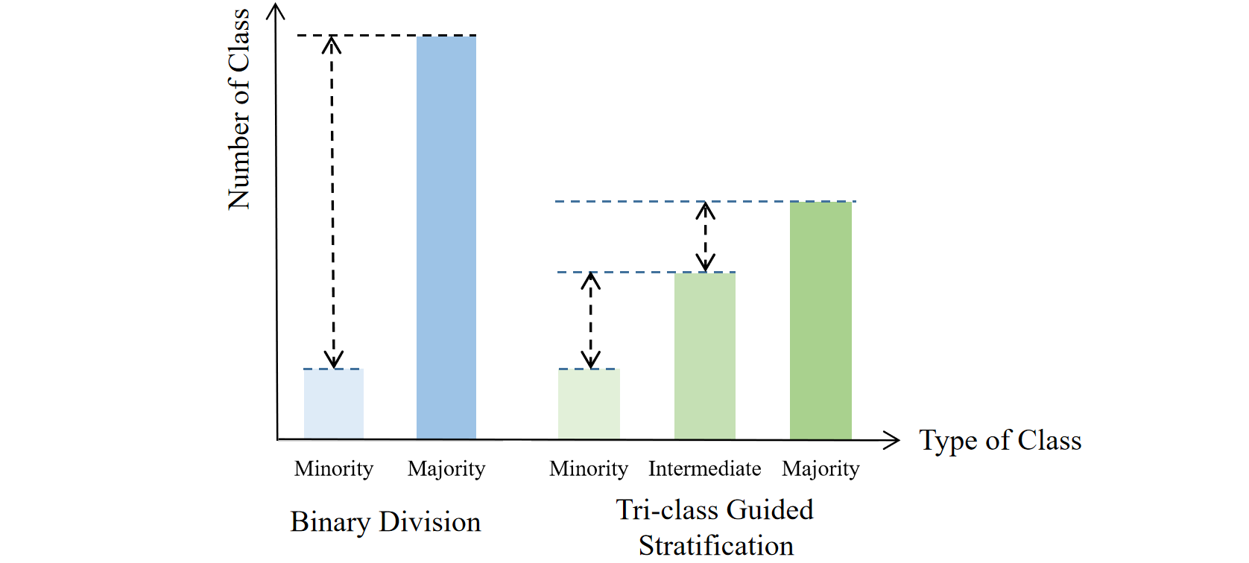
Fig. 1. The difference of traditional binary division and tri-class guided stratification. Binary division (left) forces intermediate samples into the majority class, worsening the class imbalance. The proposed tri‑class guided stratification (right) explicitly models the intermediate class, leading to a smoother class size gradient, reduced class imbalance, and enhanced identification of minority.
In multi-omics data, different omics modalities exhibit substantial differences in dimensionality and sparsity, leading to feature imbalance across molecular layers and posing a direct challenge to feature extraction. To address this issue, MOVE [9] employs a multi-omics variational autoencoder to jointly reduce the dimensionality of different modalities, thereby establishing a unified low-dimensional representation. MoGCN [10] further introduces graph convolutional networks, using an autoencoder to extract compact features and then incorporating graph structures for classification. However, such methods may overlook the distributional skew of minority-class features in high-dimensional spaces. AE-CTGAN [11] addresses this issue by introducing an autoencoder framework that performs dimensionality reduction while specifically enhancing minority-class features. Nevertheless, when faced with extremely sparse and severely skewed modality distributions, how to achieve balanced feature extraction without losing cross-omics interactions remains a problem.
The introduction of graph learning brings new challenges to imbalanced data, among which topological imbalance in graph structures has become a critical issue. Minority-class nodes often occupy structurally disadvantaged positions and receive weaker supervisory signals during message passing. To address this problem, GraphSMOTE [12] generates synthetic minority-class nodes in the embedding space and constructs edges using a learnable generator. TAM [13] adopts a different strategy by introducing topology-aware margins that adaptively adjust decision boundaries according to node connectivity patterns. In addition, ReNode [14] assigns topology-aware edge weights to minority-class nodes, rebalancing their influence during propagation and effectively mitigating the marginalization of minority classes in graph structures. Although existing methods can alleviate topological imbalance in graph-structured data, they remain limited in handling the more complex scenarios encountered in multi-omics data.
Effective fusion of multi-omics data is also essential for improving the accuracy of cancer subtype classification. MoGCN [10] combines autoencoders with graph convolutional networks for multi-omics integration. MOGONET [15] jointly explores modality-specific learning and cross-omics associations through multi-view graph neural networks. A heterogeneous multilayer graph-based multi-omics GNN framework [16] further models multi-omics data as a heterogeneous multilayer graph to embed both intra- and inter-omics connections. MMGN [17] integrates multiplex networks with pan-cancer multi-omics data, employs graph neural networks combined with negative sample inference to identify cancer driver genes, and enhances gene feature learning via mutual information and consensus regularizer. DrugCellGNN [18] concatenates multi-omics data into a PCA‑reduced feature matrix, constructs two similarity networks via weighted fusion of similarity measures, and employs a dual GCN to realize the fusion of multi-omics data. Although these methods have made progress in feature extraction and graph-based fusion, a holistic solution that simultaneously addresses class, feature and topological imbalance during the fusion process is still lacking.
To address the challenge of both data imbalance and multi-omics fusion, we propose TRIGEL (Tri-class Guided Multi-dimensional Graph Enhanced Contrastive Learning) for imbalanced cancer subtyping. TRIGEL constructs tri-class guided stratification to perform multi-dimensional graph enhancement, and applies comparative learning to multi-group data fusion for imbalanced cancer subtyping. The main contributions of this study are summarized as follows:
(1) To address class imbalance, we propose a tri-class guided stratification strategy. TRIGEL divides cancer subtypes into minority, intermediate, and majority classes according to sample proportion, capturing the internal distribution structure of data and the progressive density difference between categories more finely.
(2) We propose a multi-dimensional graph enhancement mechanism to address feature imbalance and topological imbalance simultaneously. Across the feature dimension, TRIGEL masks features according to their importance weights with class-differentiated intensity. Across the topology dimension, TRIGEL adds edges and increases edge weights for minority-class nodes, removes edges and decreases edge weights for majority-class nodes, while applying intermediate adjustments for the intermediate class. This multi-dimensional strategy mitigates multi-omics data imbalance while preserving critical discriminative structures and distributional information.
(3) Facing the challenge of multi-omics data fusion, we design a contrastive learning framework for imbalanced cancer subtyping. TRIGEL aligns the augmented multi-omics views under class-balanced objectives, and fuses modality-specific representations through node-level attention. This framework simultaneously achieves cross-omics integration and imbalance mitigation, allowing the two objectives to reinforce each other within a unified pipeline.
Experiments on multiple public multi-omics cancer datasets demonstrate that TRIGEL improves imbalanced cancer subtype classification compared with representative imbalance-learning, graph-based, and multi-omics fusion methods. Further ablation studies show that tri-class guided stratification, multi-dimensional graph enhancement, and contrastive fusion classification all contribute to more balanced and discriminative multi-omics representations.
- Related Work
In multi-omics cancer subtype classification, effective integration of multi-omics data and handling of data imbalance are two coupled key challenges. In recent years, researchers have also addressed one or two aspects of data imbalance when integrating multi-omics data. For example, MMGN integrates multiplex networks and pan-cancer multi-omics data using graph neural networks combined with negative sample inference, which not only enhances gene feature learning based on the mutual information and the consensus regularizer, but also achieves balanced class of positive and negative samples for model training. However, it does not correct for feature imbalance arising from differences in dimensionality and sparsity across omics modalities, nor does it address topological imbalance such as skewed node degree distributions and disadvantaged message-passing positions. DrugCellGNN integrates multi-omics data with drug features and adopts a dynamic Focal Loss that adjusts weights according to class classification difficulty, addressing class imbalance at the loss function level. Nevertheless, it does not involve differentiated augmentation of node features, nor does it consider topological imbalance.
These methods have made significant contributions to solving multi-omics data integration and data imbalance, but their handling of data imbalance covers only one or two levels. As a result, they struggle to simultaneously address the three imbalance levels of class, features, and topology. Therefore, we propose TRIGEL, a method that effectively integrates multi-omics data while simultaneously accounting for class, feature, and topological imbalances. TRIGEL addresses these three imbalance levels through a tri-class guided strategy and a multi-dimensional graph enhancement mechanism. At the same time, TRIGEL ensures effective multi-omics integration via multi-omics views augmented by contrastive learning mechanism, allowing imbalance mitigation and multi-omics fusion to reinforce each other within a unified framework.

3. The Proposed Method
The TRIGEL framework addresses imbalanced multi-omics cancer subtype classification through three interconnected components: Tri-class Guided Stratification (TGS), Multi-dimensional Graph Enhancement (MGE), and Contrastive Fusion Classification (CFC). TGS constructs a patient graph with compact node features for each omics modality and assigns cancer subtypes to minority, intermediate, and majority groups according to their sample sizes. This stratification guides MGE in applying group-specific feature and topology enhancement to each omics graph. CFC then aligns the representations learned from the original and enhanced graph views through contrastive learning. A class-balanced classification loss reduces majority-class bias, while node-level self-attention dynamically integrates the modality-specific representations to predict the cancer subtype. The overall architecture of TRIGEL is illustrated in Fig. 2.
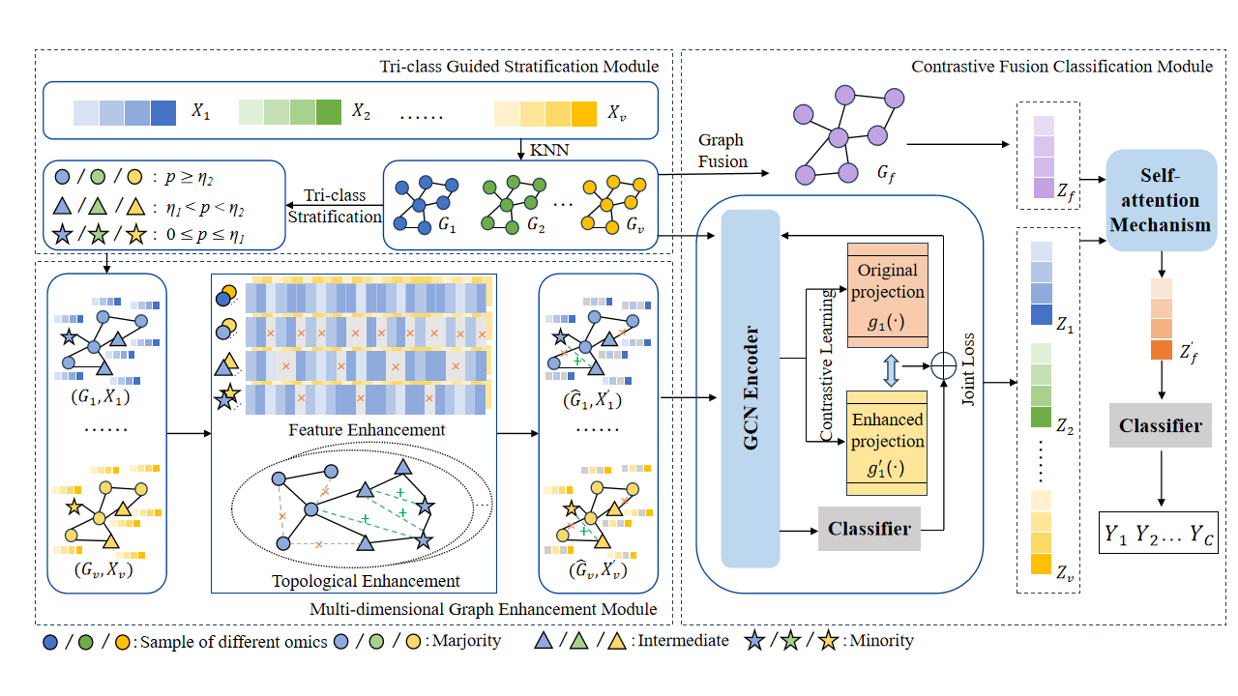
Fig. 2. Architecture of TRIGEL. For each omics modality $v$, TRIGEL constructs an original patient graph $G_{v}$ using KNN and stratifies the cancer subtypes into minority, intermediate, and majority groups according to their sample sizes. Guided by this stratification, group-specific feature and topology enhancement generates an enhanced graph ${\hat{G}}_{v}$. The original and enhanced graph views are encoded and aligned through contrastive learning to obtain consistent patient representations. The modality-specific representations are subsequently weighted and integrated through node-level self-attention to produce the fused representation $Z_{f}$ for cancer subtype classification.

3.1 Tri-class Guided Stratification
TGS converts the data from each omics modality into a patient similarity graph and stratifies the cancer subtypes according to their sample sizes. The resulting group assignments provide the class-aware guidance used by MGE.

3.1.1 Patient Similarity Graph Construction
For each of the $V$ omics modalities, we construct a patient similarity graph using k-nearest neighbors (KNN)[19]. Let $X_{v}∈ℝ^{N×D_{v}}$ denote the feature matrix of omics modality $v$, where $N$ represents the number of patients and $D_{v}$ denotes the feature dimension. For a given omics modality, the cosine similarity between patients $p$ and $q$ is computed as:
$$sim\left(x_{p}^{(v)},x_{q}^{(v)}\right)=\frac{{\left(x_{p}^{(v)}\right)}^{⊤}x_{q}^{(v)}}{{\left\|x_{p}^{(v)}\right\|}_{2}{\left\|x_{q}^{(v)}\right\|}_{2}} (1)$$
where $x_{p}^{(v)}$ and $x_{q}^{(v)}$ are the feature vectors of patients $p$ and $q$ in omics modality $v$, respectively, and $‖⋅‖$ denotes the $L_{2}$ norm. Based on the computed similarities, we identify the k nearest neighbors for each patient and construct the adjacency matrix $A_{v}∈\{0,1\}^{N×N}$. Self-loops are incorporated to allow nodes to retain their own features during graph convolution. The patient similarity graph constructed by KNN captures local patient relationships within each omics.

3.1.2 Tri-class Guided Stratification
To enable differentiated treatment across cancer subtypes with varying sample sizes, we introduce a tri-class guided stratification strategy. For a classification task with $C$ cancer subtypes, let $n_{c}$ denote the number of training samples belonging to subtype $c$, and let $N_{train}$ denote the total number of training samples. The sample proportion of subtype $c$ is defined as:
$$p_{c}=\frac{n_{c}}{N_{train}} \text{(}\text{2}\text{)}$$
Based on $p_{c}$, subtype $c$ is assigned to the minority group if $p_{c}≤η_{1}$, the intermediate group if $η_{1}<p_{c}<η_{2}$, and the majority group if $p_{c}≥η_{2}$, where $η_{1}$ and $η_{2}$ are predefined thresholds. Compared with the conventional binary division, this stratification explicitly represents subtypes with moderate sample sizes and provides finer-grained guidance for subsequent graph enhancement.
Following Cui et al. [22], we use the effective number of samples to account for the diminishing marginal benefit of additional samples within each subtype. The effective number of samples for subtype $c$ is defined as:
$$E_{c}=\frac{1−β^{n_{c}}}{1−β} \text{(}\text{3}\text{)}$$
where $β∈[0,1)$ controls the degree of diminishing marginal benefit as the sample size increases. When $β=0,E_{c}=1$ for all subtypes. As $β$ approaches 1, $E_{c}$ approaches the actual sample count $n_{c}$. Building on this effective-number formulation, TRIGEL further incorporates the tri-class group assignment into the subtype weight:
$$w_{c}=\frac{τ_{t(c)}}{E_{c}⋅\bar{w}} \text{(}\text{4}\text{)}$$
where $t(c)∈\{minority,intermediate,majority\}$ denotes the group assignment of subtype $c$, and $τ_{t(c)}$ is the corresponding group-specific multiplier. The normalization factor$\bar{w}=\frac{1}{C}\sum_{j=1}^{C}{\frac{τ_{t(j)}}{E_{j}}}$
ensures that the mean weight across all subtypes equals one. This weighting scheme combines the continuous frequency information captured by the effective number of samples with the discrete group information produced by TGS.

3.2 Multi-dimensional Graph Enhancement
MGE mitigates feature and topological imbalance by enhancing each original graph $G_{v}=(X_{v},A_{v})$ along the feature and topology dimensions. The two enhancement operations are guided by the group assignments produced by TGS and are applied to training nodes only. They produce an enhanced graph ${\hat{G}}_{v}=({\hat{X}}_{v},{\hat{A}}_{v},W_{v})$, where ${\hat{X}}_{v}$ is the enhanced feature matrix, ${\hat{A}}_{v}$ is the modified adjacency matrix, and $W_{v}$ contains the class-aware edge weights. Validation and test nodes retain their original features and connections.

3.2.1 Class-Guided Feature Enhancement
Class-guided feature enhancement retains more information for minority-group nodes, applies moderate masking to intermediate-group nodes, and more strongly suppresses low-significance features for majority-group nodes. Feature significance is estimated by combining feature magnitude with node centrality in the original patient graph.
Node centrality is measured using the PageRank algorithm on the original patient similarity graph:
$$PR(i)=α\sum_{j∈N(i)}{\frac{A_{ji}}{d_{j}^{out}}}PR(j)+\frac{1−α}{N} \text{(}\text{5}\text{)}$$
where $α∈(0,1)$ is the damping factor, $N(i)$ denotes the set of nodes connected to node $i$, $A_{ji}$ indicates whether an edge exists from node $j$ to node $i$, and $d_{j}^{out}=\sum_{k=1}^{N}{A_{jk}}$ is the out-degree of node $j$. $N$ denotes the total number of nodes. Because the patient graphs are undirected, $A_{ji}=A_{ij}$.
Based on the PageRank scores, the structural significance score of feature dimension $f$ is defined as:
$$s_{f}=\sum_{i=1}^{N}{|}x_{if}|⋅PR(i) \text{(}\text{6}\text{)}$$
where $x_{if}$ denotes the value of feature $f$ for node $i$. A larger $s_{f}$ indicates that feature $f$ has a larger magnitude among structurally prominent nodes and is therefore assigned greater significance during feature masking.
To convert $s_{f}$ into a masking probability, we first apply the logarithmic transformation $s_{f}=\log{(}s_{f}+ϵ)$, where $ϵ$ is a small positive constant introduced for numerical stability. The relative masking score of feature $f$ is then computed using reverse min-max normalization:
$$ρ_{f}=\frac{s_{f,max}−s_{f}}{s_{f,max}−s_{f,min}+ϵ} \text{(7)}$$
where $s_{f,max}$ and $s_{f,min}$ denote the maximum and minimum transformed structural-significance scores across all feature dimensions, respectively. This normalization constrains $ρ_{f}$ to approximately $[0,1]$. A larger $ρ_{f}$ indicates lower structural significance and therefore a greater tendency to be masked.
The masking probability of feature $f$ for a training node $n$ is defined as:
$$p_{drop}^{(n)}(f)=min(\sqrt{ρ_{f}⋅r_{t(y_{n})}},0.9) \text{(}\text{8}\text{)}$$
where $y_{n}$ is the subtype label of node $n$, $t(y_{n})$ denotes its minority, intermediate, or majority group, and $r_{t(y_{n})}∈[0,1]$ is the corresponding group-specific drop rate. A Bernoulli mask is sampled according to $p_{drop}^{(n)}(f)$, and the masked node features form the enhanced feature matrix ${\hat{X}}_{v}$. The upper bound of 0.9 prevents all feature information from being removed.

3.2.2 Class-Aware Topology Augmentation
Class-aware topology augmentation adjusts graph connectivity and propagation strength according to the group assignment provided by TGS. Specifically, new edges are introduced for minority-group nodes to expand their neighborhoods, weak edges are removed from intermediate- and majority-group nodes to suppress redundant propagation, and group-specific weights are assigned to the resulting edges.
For each minority-group training node $n$, candidate nodes are selected from the high-centrality set $ℋ=\{j:PR(j)≥PR_{75}\}$, excluding existing neighbors and the node itself. Each candidate is evaluated according to both feature similarity and structural centrality.
$$score(n,j)=λ⋅sim(x_{n},x_{j})+(1−λ)⋅\tilde{PR}(j) \text{(}\text{9}\text{)}$$
where $\tilde{PR}(j)=PR(j)/PR_{max}$, $λ∈[0,1]$ balances the two terms, and $PR_{max}$ is the maximum PageRank score. The adjacency matrix is then updated as:
$${\hat{A}}_{nj}=\left\{\begin{aligned}1,{ A}_{nj}^{(v)}=0,t(y_{n})=minority, score(n,j)>θ, u<p_{add}, \\ 0,{ A}_{nj}^{(v)}=1,t(y_{n})∈\{intermediate,majority\}, sim(x_{n},x_{j})<δ, u<p_{rem}, \\ A_{nj},otherwise,\end{aligned}\right. (10)$$
where $u∼U(0,1)$, $θ$ and $δ$ are the thresholds for edge addition and removal, respectively, and $p_{add}$ and $p_{rem}$ control the corresponding augmentation probabilities. Since each patient graph is undirected, every edge addition or removal is simultaneously applied to both ${\hat{A}}_{nj}^{(v)}$ and ${\hat{A}}_{jn}^{(v)}$.
To further regulate information propagation, each edge is assigned the higher-priority group of its two endpoints, following minority $>$ intermediate $>$ majority. Its structural quality is defined as:
$$q(n,j)=\frac{PR(n)+PR(j)}{2PR_{max}} \text{(11)}$$
The final edge weight is computed as:
$$w(e_{nj})=τ_{e}\left(t(e_{nj})\right)κ(e_{nj})\left[1+γq(n,j)\right] \text{(12)}$$
where $τ_{e}$ is the group-specific base weight, satisfying $τ_{e}(minority)>τ_{e}(intermediate)>τ_{e}(majority)=1$. The subtype-consistency factor is set to $κ(e_{nj})=κ>1$ when $y_{n}=y_{j}$, and to $κ(e_{nj})=1$ otherwise, thereby assigning larger weights to edges connecting patients from the same cancer subtype, while $γ$ controls the influence of structural quality. All edge weights are clipped to $[\text{0.5,5.0}]$.
Together with feature enhancement, this procedure produces an enhanced graph ${\hat{G}}_{v}=({\hat{X}}_{v},{\hat{A}}_{v},W_{v})$ for each omics modality.

3.3 Contrastive Fusion Classification
CFC takes the original graph set $G=\{G_{1},…,G_{V}\}$ and the enhanced graph set $\hat{G}=\{{\hat{G}}_{1},…,{\hat{G}}_{V}\}$ as input. It first extracts modality-specific representations from both graph views, then aligns the two patient representations through contrastive learning, and finally integrates complementary omics information through node-level self-attention for subtype classification.

3.3.1 Contrastive Representation Learning
For omics modality $v$, the original and enhanced graphs are processed by the same modality-specific GCN encoder $f_{v}(⋅)$:
$$H_{v}=f_{v}(G_{v}), {\hat{H}}_{v}=f_{v}({\hat{G}}_{v}) \text{(13)}$$
where $H_{v}$ and ${\hat{H}}_{v}$ are the node-representation matrices obtained from the two views. Unit edge weights are used for $G_{v}$, whereas ${\hat{G}}_{v}$ uses the edge weights $W_{v}$ defined in Eq. (12). Different omics modalities use separate encoders to preserve modality-specific graph patterns, while the original and enhanced views of the same modality share encoder parameters.
For each view, the modality-specific node representations are fused and concatenated as described in Section 3.3.2. A two-layer projection head maps the resulting patient representations to $L_{2}$-normalized embeddings $z_{n}$ and ${\hat{z}}_{n}$. Representations of the same patient across the two views form a positive pair, whereas representations of different patients form negative pairs. For the training patients, define the cross-view similarity matrix $S$ by $S_{nj}=z_{n}^{⊤}{\hat{z}}_{j}/τ$. The bidirectional contrastive loss is
$$ℒ_{con}=\frac{1}{2}\left[CE\left(S,y^{id}\right)+CE\left(S^{⊤},y^{id}\right)\right] \text{(14)}$$
where $τ>0$ is the contrastive temperature, $CE$ denotes row-wise cross-entropy, and $y^{id}$ identifies the diagonal entries of $S$ as positive pairs. This objective preserves patient identity across the class-aware feature and topology perturbations.

3.3.2 Multi-omics Fusion and Classification
Because the contribution of each omics modality can vary among patients, CFC estimates patient-specific modality weights using multi-head self-attention. Let ${\tilde{h}}_{n,v}=Φ_{v}h_{n,v}$ be the transformed representation of patient $n$ from modality $v$, and let ${\bar{h}}_{n}=V^{−1}\sum_{v=1}^{V}{{\tilde{h}}_{n,v}}$. For attention head $k$, the query is constructed from ${\bar{h}}_{n}$, whereas the key is constructed from ${\tilde{h}}_{n,v}$. The modality weight is
$$α_{n,v}=\frac{1}{K}\sum_{k=1}^{K}{{softmax}_{v}}\left(\frac{{\left(q_{n}^{(k)}\right)}^{⊤}k_{n,v}^{(k)}}{ξ\sqrt{d_{k}}}\right) \text{(15)}$$
where $K$ is the number of attention heads, $d_{k}$ is the dimension of each head, and $ξ>0$ controls the sharpness of the attention distribution.
The fused representation and the final multi-omics representation of patient $n$ are
$$\begin{matrix}h_{n}^{F} & =LN\left[W_{O}\left(\sum_{v=1}^{V}{α_{n,v}}{\tilde{h}}_{n,v}\right)+{\bar{h}}_{n}\right], \\ r_{n} & =Concat\left(h_{n,1},h_{n,2},…,h_{n,V},h_{n}^{F}\right)\end{matrix} \text{(16)}$$
where $W_{O}$ is the output projection and $LN$ denotes layer normalization. The same operation is applied to the enhanced view to obtain ${\hat{r}}_{n}$. The enhanced-view representation ${\hat{r}}_{n}$ is passed to the classifier, and the subtype weight $w_{y_{n}}$ defined in Eq. (4) is incorporated into the cross-entropy loss $ℒ_{cls}$.
The complete training objective is
$$ℒ=λ_{cls}ℒ_{cls}+λ_{con}ℒ_{con} \text{(17)}$$
where $λ_{cls}$ and $λ_{con}$ control the contributions of subtype classification and cross-view alignment, respectively. Thus, CFC combines class-balanced supervision, augmentation-invariant representation learning, and patient-specific multi-omics fusion within a unified objective.

